**JavaScript HTML DOM (Document Object Model)**

When a webpage is loaded, the browser creates a DOM of that page.

The HTML DOM model is constructed as a tree of **Objects**

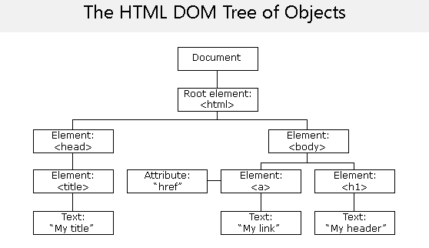

By using this DOM, JavaScript gets all the power it needs to create the dynamic webpage.

* JavaScript can change all the HTML elements in the page
* JavaScript can change all the HTML attributes in the page
* JavaScript can change all the CSS styles in the page
* JavaScript can remove existing HTML elements and attributes
* JavaScript can add new HTML elements and attributes
* JavaScript can react to all existing HTML events in the page
* JavaScript can create new HTML events in the page

What is DOM?

DOM is a World Wide Web Consortium standard for accessing documents.

“*"The W3C Document Object Model (DOM) is a platform and language-neutral interface that allows programs and scripts to dynamically access and update the content, structure, and style of a document."*

W3C DOM standards separated into 3 parts

Core DOM: - Standard model for all document type

XML DOM: - Standard model for XML document type

HTML DOM: - Standard model for HTML document type

HTML DOM: -

The HTML DOM is a standard for how to get, change, add, or delete HTML elements.

HTML DOM has methods and values

Methods: - Actions performed on HTML element

Property: - Values you can set or get from HTML element

Most common HTML DOM method & Property you will come across is getElementById() and innerHTML

Ex-

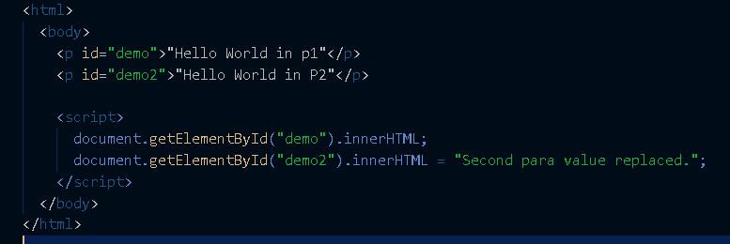

In webpage:-

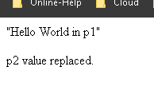

Here we have two paragraphs and we are differentiating with id names.by using id names only we are accessing the value of one para content and changing the content of another one.

Changing the HTML output stream

<!DOCTYPE html>

<html>

  <body>

    <script>

      document.write(*Date*());

    </script>

  </body>

</html>

Output: -

